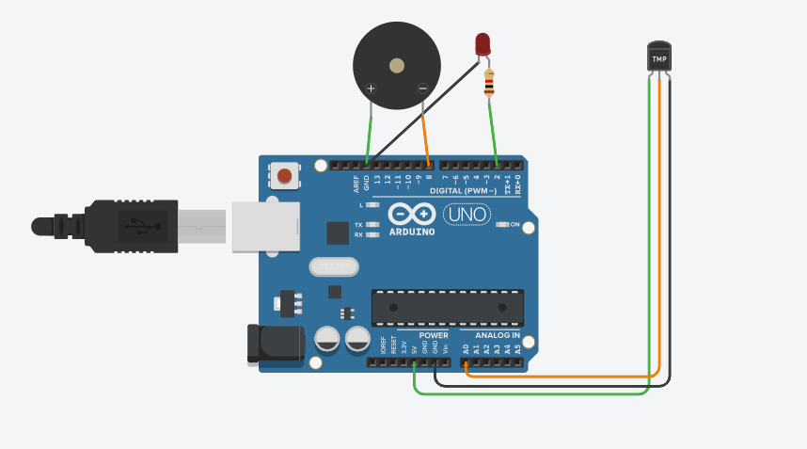

void setup()
{
Serial.begin(9600);
pinMode(8, OUTPUT);
pinMode(A0, INPUT);
pinMode(2, OUTPUT);
}
void loop()
{
int temp = analogRead(A0);
if (temp>50)
{
tone(8, 1000);
digitalWrite(2, HIGH);
delay(2000);
}
else
{
noTone(8);
digitalWrite(2,LOW);
delay(2000);
}
}

